Testing Strategy for Tic-Tac-Toe

What do I need to test?
Goal:
- Every function needs to be implemented correctly
- The whole program can run as intended

How to test?
To test the whole program, the first thing that comes to my mind is to test manually. During development I will frequently run the program and play the game to make sure that changes in the code shouldn’t affect the whole game.
But if somehow things break, it means that either the implementation of some functions are wrong or some other problems that I don’t know of (maybe some code that is using other functions expect different results…)
But to clearly know what went wrong and where, we need to have tests for each function separately from the rest of the system. For example, an int makeMove(Board board) function expects the board as an input, and return a valid integer as a result. So maybe we would write test functions that give some boards as inputs and check if the output is correct based on what the intended behaviour is. I’m not sure if we can “simulate human input” during testing.
Another more concrete example is the checkWinner() function. We can give the board many states and check if the board is checking the winner correctly.
I would suppose these (I think) “unit tests” are run every time we run the whole program. This observation is from every time I run mvn package (which is an alternative to mvn clean install that is proposed to me by ChatGPT for faster execution), I see this:
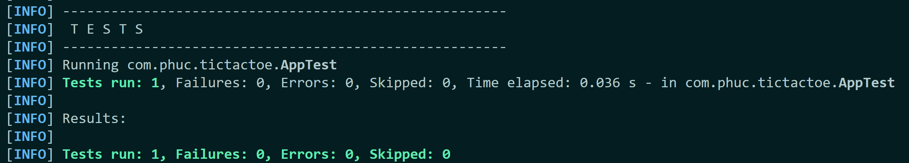
So I can see one auto-generated test have been written for me in the AppTest.java file
package com.phuc.tictactoe;
import org.junit.jupiter.api.Test;
import static org.junit.jupiter.api.Assertions.*;
public class AppTest {
@Test
public void shouldAnswerWithTrue() {
assertTrue(true);
}
}

I would guess writing other tests here would make it run every time I compile the project.
I’m not sure if we need to test Constructors. It seems trivial enough to not test, but if somehow the constructors break and we don’t have tests to catch that, it will be disastrous. Same for the main function but I suppose the main function is tested manually by me every time I compile the project. If there is a way to automate that as well then less work for me.

